HOME SCREEEN

GARBAGE COLLECTION SCHEDULE SCREEN

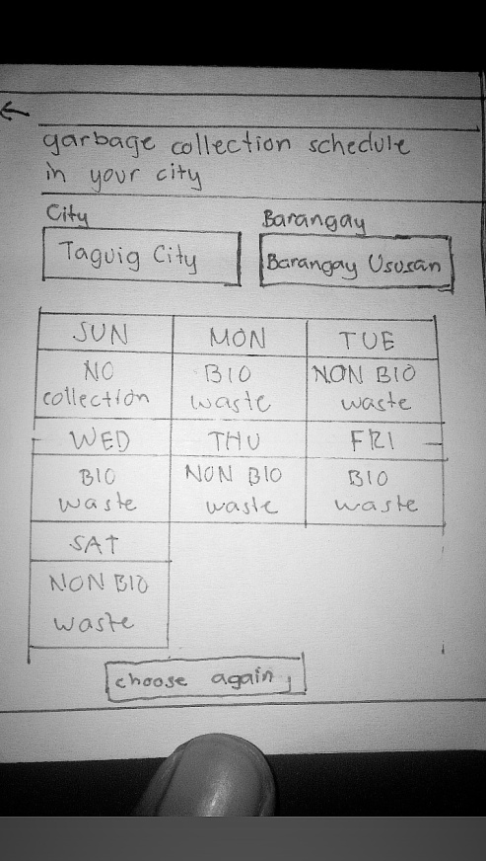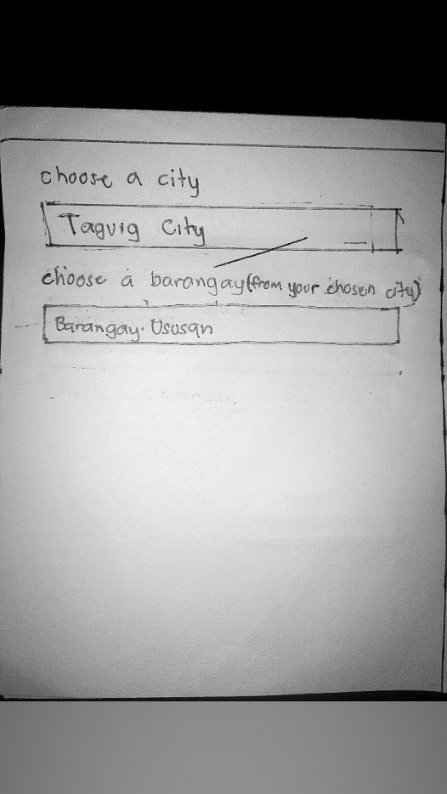

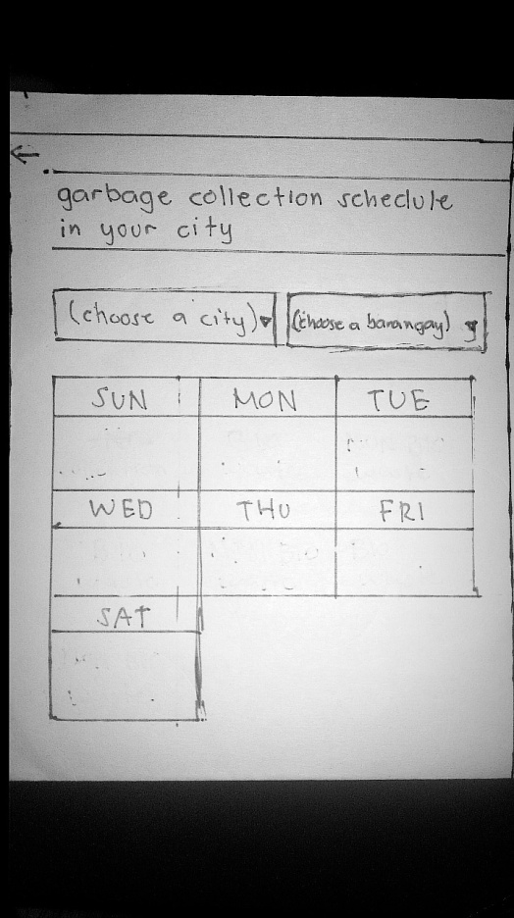

IMPORTANCE OF WASTE SEGAREGATION SCREEN

MANAGAE HOME WASTE SCREEN

TRASH BIN GUIDE SCREENS

